|  |
| --- |
| MJ Logistics Gaming Company |
| CRM Solution |
| D284 |

|  |
| --- |
| Nia Bourgeois  11-1-2023  Version 1 |

Contents

A. Introduction 3

A1. Introduction and Purpose Statement 3

A2. Overview of the Problems 3

A3. Goals and Objectives 3

A4. Prerequisites 3

A5. Scope 3

A6. Environment 4

B. Requirements 4

Business Requirements 4

User Requirements 4

Functional Requirements 4

Non-Functional Requirements 5

C. Software Development Methodology 5

C1. Advantages and Disadvantages 5

Advantages of the Agile Method 5

Disadvantages of the Agile Method 5

Advantages of the Waterfall method 5

Disadvantages of the waterfall method 5

C2. Best suited 6

D. Create Two Representations of the Software Solution 6

Representation 1 6

Representation 2 8

E. Testing 8

Performance test 8

Functional test 9

Usability test 10

# Introduction

# A1. Introduction and Purpose Statement

The primary purpose of the proposed system is to improve areas of MJ Logistics that will allow MJ Logistics to continue providing top tier services to its clients. In this proposal, requirements, methodologies, testing will be discussed.

The purpose of this document is to provide solutions for MJ Logistics Gaming Company to address requirements for a new system. The proposed software solution is an adaptable, efficient CRM system comprising effective data management, task automations, and seamless user interaction.

# A2. Overview of the Problems

MJ Logistics currently has problems with their system integration capabilities, processing, and strains due to its recent growth, as sales has increased by 42%. This proposed solution will address MJ Logistics through the integration of cloud systems that will allow for scalability, and implantation of efficient database that will allow for data manipulation, and systems to handle multiple tasks.

# A3. Goals and Objectives

The goals and objectives of proposed CRM solution:

* Be scalable for wide range of users
* Be efficient on various tasks
* Have robust data management system

The overall goal for this proposed CRM solution is to deliver an adaptable and efficient CRM system that will accommodate MJ Logistics’ needs for their growing user base.

# A4. Prerequisites

|  |  |  |  |
| --- | --- | --- | --- |
| Number | Prerequisite | Description | Completion Date |
| 1 | Analysis | Conduct analysis of MJ logistics’ current systems and gather data for areas in need of improvement | 11/15/23 |
| 2 | Data | Package and backup data so that it is prepared to be loaded into new system | 12/1/23 |

# A5. Scope

These are in the scope of this proposed system:

* Accurate data reporting system
* Capacity for high usage
* Efficient ticketing system
* Solutions for off-site hosting

These are out of the scope of this proposed system:

* Integration of artificial intelligence
* Hardware upgrades

# A6. Environment

The system employed with the following front-end environments:

* API integration
* User interface
* HTML/CSS3

The front end will be designed to be compatible with a large range of web browsers such as Google Chrome, Mozilla Firefox, and Microsoft Edge. It will also be compatible with devices such as desktops, laptops, and tablets.

The system employed with the following back-end environments:

* API development
* My SQL
* Express.js
* Java

The back end environment will be deployed using high end servers with multi-core processors as well high levels of storage. Additionally, a robust networking system will be included to ensure the efficiency of the databases. There will also be redundancy for storage and backups to ensure that no data will be lost in the case of an emergency.

These environments will work together to create a comprehensive and efficient CRM system that will improving MJ Logistics’ data storage, user interface, and more.

# Requirements

These are the four requirements that will be discussed below:

1. Reporting
2. User
3. Ticketing System
4. Hosting

## Business Requirements

The Reporting aspect requires that the new system be capable of handling data in various reports and have a user interface that allows for data manipulations and other tasks. Our system will incorporate an analytics engine that collects various data that will be accessible through a user-friendly interface for easy access. For example, our reporting system will enable data tracking of users over time which will provide insights that will help the company.

## User Requirements

The User aspect requires that the system be scalable so that at least 500 users can access is at the same time. Our system will implement a scalable solution, utilizing cloud- based services such as AWS Elastic Beanstalk to accommodate many users simultaneously. For example, during times of high usage, all users will be able to access the systems with no lags or delays.

## Functional Requirements

The Ticketing System aspect requires that all communication or contact inquiries are recorded in a ticketing system. Our system will integrate a database that is able to track each tick and its corresponding information in an organized manner. For example, if a user has a problem, they can reach out to the support team and submit a ticket. From there the ticket and corresponding information will be recorded in the database for future reference.

## Non-Functional Requirements

The Hosting aspect requires that off-site, cloud-based solutions incorporate various maintenance, upgrade, and support solutions. It also requires that sandbox be provided for testing and development. Our system will fulfill these requirements by utilizing leading cloud services to ensure adequate delivery and handling. For example, this setup will guarantee seamless updating, maintenance, improvements, etc. Additionally, a sandbox environment will be established for testing and development.

# Software Development Methodology

Here, the agile methodology will be compared to the waterfall method through exploring the advantages and disadvantages of each. Then we will discuss with methodology will be best for MJ Logistics Gaming Company.

# C1. Advantages and Disadvantages

## Advantages of the Agile Method

Three advantages of the Agile method include:

1. Flexibility allows for change
2. Project failure risk reduced
3. Increments allow for feedback as project is developed

## Disadvantages of the Agile Method

Three disadvantages of the Agile method include:

1. Flexibility leads to less predictability
2. Requires stakeholders to be available for feedback
3. Not suitable for well-defined projects

## Advantages of the Waterfall method

Three advantages of the Waterfall method include:

1. Stability allows for accurate timeline and budget estimates
2. Ensuring thoroughness of each stage allows for next stage to be built on a stable base
3. Provides easy and clear management through the step by step process

## Disadvantages of the waterfall method

Three disadvantages of the Waterfall method include:

1. Not accommodating to changes during the stage development
2. Project delivery takes longer
3. Prone to failure if there is any miscommunication/misunderstanding

# C2. Best suited

Because MJ Logistics Gaming is a company that provides gaming services to the public, it is important that they develop a project that is sure to fulfill every requirement without failure. Thus, it is crucial that a methodology is chosen that will provide the least risk possible, while delivering in a timely manner. The agile method, as discussed above, holds the advantage of being adaptable to changes, lowing project failure risks. Additionally, it is timely so that the project may be implement as soon as possible, ensuring that MJ Logistics Gaming Company does not fall behind .

# Create Two Representations of the Software Solution

Below are representations in the format of a flowchart and a GUI.

## Representation 1

Below is a flowchart representation of the ticketing system. This ticketing system will allow users to connect to a support representative and get help in a timely manner.

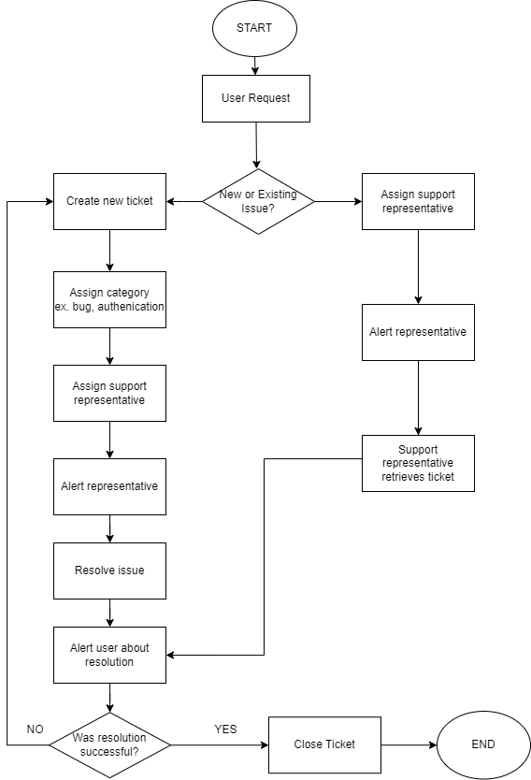

## Representation 2

This is representation of the GUI for the login screen. This is a user friendly interface that will allow users to access their account with their login information.

# Testing

# Performance test

|  |
| --- |
| **Requirement to be tested:**  Test whether the system can handle an abundance of login requests simultaneously. |
| **Preconditions:**  Program to simulate login requests is prepared  System login is prepared and ready to accept requests |
| **Steps:**   1. Execute program to send 170 login requests simultaneously 2. Check system performance and response time 3. Execute program to send 170 login requests simultaneously 4. Check system performance and response time 5. Execute program to send last 160 login requests simultaneously 6. Check system performance and response time |
| **Expected results:**  The expected results include all simulations able to login without experiencing lag or delay. At the time of the last simulation group login, the system’s performance and response times should remain consistent with the first group’s login. |
| **Pass/Fail: Explain why the test case passed or failed.**  PASS: There was no experience of lag or delay in the sessions. This test shows that the system is capable of handling large loads of users simultaneously. |

# functional test

|  |
| --- |
| **Requirement to be tested:**  The ticketing system functionality will be tested. |
| **Preconditions:**  Ticketing system should be available  Ticket entries to be submitted |
| **Steps:**   1. Submit three ticket entries 2. Verify that the ticket is recorded in the database 3. Verify that each ticket has alerted a support representative 4. Verify that a representative can retrieve and review ticket so they can take the appropriate steps |
| **Expected results:**  After a user creates a ticket, a support representative should be able to access the ticket and take the next appropriate steps. This may include searching for another ticket or notifying user of resolution. |
| **Pass/Fail:**  PASS: Ticket system successfully records user’s inputted data and notifies support representative for assistance in a timely manner. |

# usability test

|  |
| --- |
| **Requirement to be tested:**  The reporting will be tested for usability and accurate recording |
| **Preconditions:**  Various sample data available (ex. Username, birthdate, email)  Various users (admin, developer, analysts) |
| **Steps:**   1. Generate reports using sample data 2. Use interface to sort, filter, and query data 3. Verify accuracy of the results from each manipulation 4. Test with various users (admin, developers, analysts) |
| **Expected results:**  Results are expected to show accurate information being pulled and being manipulated accurately based od user’s instruction. Additionally, each user will be able to use the interface with no trouble, proving the interface is user friendly. |
| **Pass/Fail:**  PASS: Each user was able to utilize the reporting system and manipulate data as intended. That data that was stored and manipulated proved to be accurate after verification. |